BIT/2024/73820
Week 4 Documentation:
Implementing Crud operations, Create, read, update and delete to the developed application, Flutter fitness app Shredded Squad, by building a data management module for managing user’s personal records backed by local SQLite database.
Personal records display screen – Once records are logged in, they are saved in the database and displayed in this screen
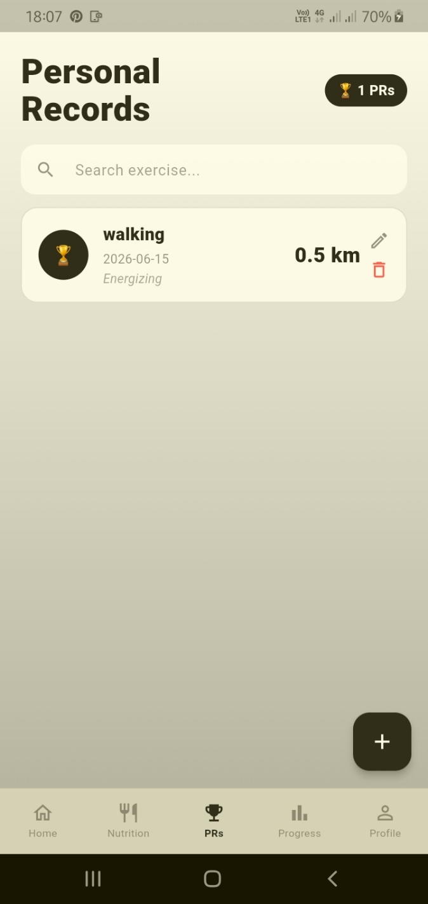

Search element- This is where users can search for PR records located in the storage in a search bar

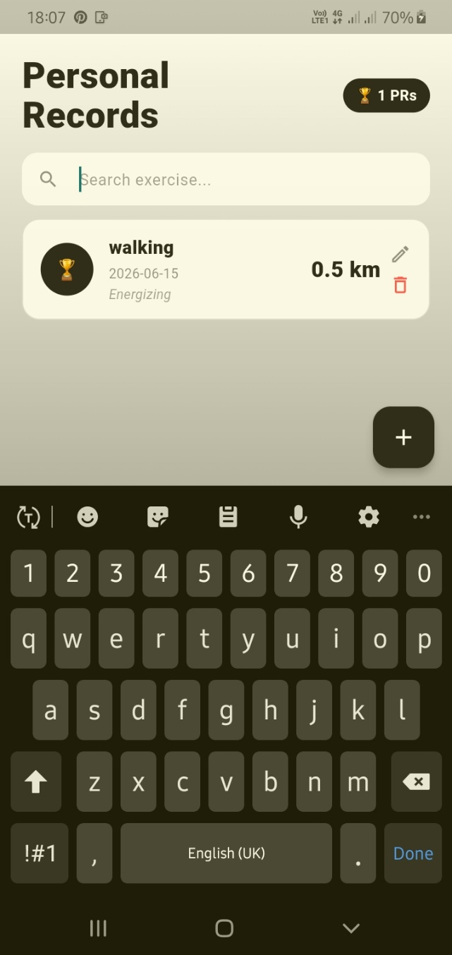

Records insertion- is done by taping the + widget to log in new records
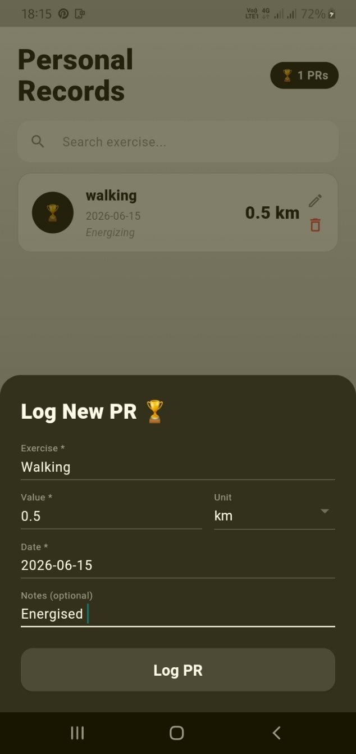

Records Update- Where saved records are edited, denoted by the pencil widget
